Project Report Format
- INTRODUCTION
  - Project Overview
DarshanEase – Temple Darshan Ticket Booking System is a web-based application designed to simplify the process of booking temple darshan slots. The system is developed using the MERN stack, which consists of MongoDB, Express.js, React.js, and Node.js.

In many temples, devotees are required to stand in long queues to obtain darshan tickets. This traditional system often results in crowd congestion, inefficient time management, and inconvenience for visitors. The DarshanEase platform addresses this issue by providing a digital solution that enables devotees to book darshan slots online.

The system provides a user-friendly interface where users can browse temple information, check available darshan timings, and reserve their preferred slots in advance. Additionally, the application allows users to view their booking history and make donations to temples through the platform.

From the administrative perspective, the system provides an Admin Dashboard that enables temple administrators to manage temple information, create darshan slots, and monitor bookings effectively.
Overall, DarshanEase aims to improve the temple visit experience by combining convenience, efficiency, and digital accessibility.

  - Purpose
The purpose of the DarshanEase system is to improve the temple visit experience by providing an online booking platform. The system helps reduce waiting time, improves crowd management, and provides convenience to devotees.
Main objectives include:
- Providing online darshan slot booking
- Reducing long queues at temples
- Improving visitor management
- Allowing users to make donations online

- IDEATION PHASE
  - Problem Statement
Many temples still rely on traditional ticket booking systems where devotees must stand in long queues to obtain darshan tickets. This causes inconvenience, poor crowd management, and difficulty in planning temple visits.
DarshanEase aims to solve this problem by providing an online platform where devotees can book darshan slots in advance.

  - Empathy Map Canvas
Customer: Temple visitors and devotees.
Think: Want a convenient and organized temple visit.
Feel: Frustrated due to long waiting queues.
Say: There should be an easier way to book darshan slots.
Do: Visit temples physically and wait for tickets.
The system addresses these issues by providing an online booking solution.
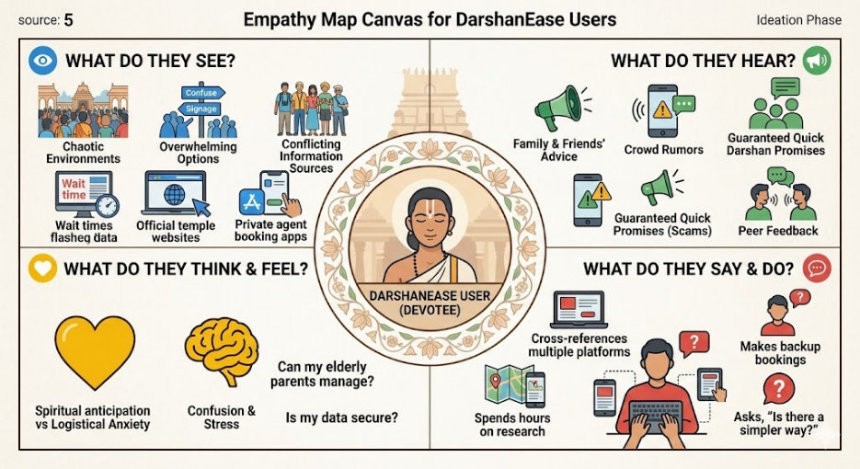
Figure 1: Empathy Map Canvas for DarshanEase Users

  - Brainstorming
During the brainstorming phase, the project team analyzed various approaches to solving the identified problem. Several ideas were discussed, including developing a mobile application, implementing a digital ticketing system, and creating an online booking platform.
After evaluating these options, the team decided to develop a web-based platform that allows users to:
- Register and log into the system
- Browse temples and available darshan slots
- Book darshan tickets online
- Manage their bookings
- Make donations digitally
This solution was chosen because it is accessible, scalable, and easier to implement using modern web technologies.
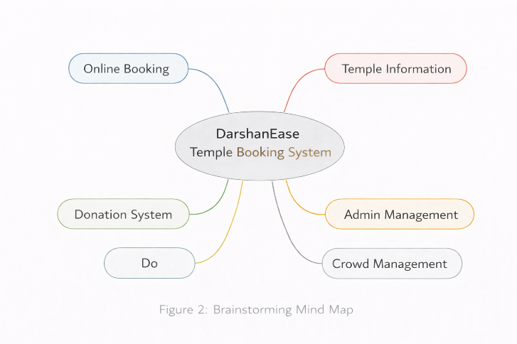
Figure 2: Brainstorming Mind Map

- REQUIREMENT ANALYSIS
  - Customer Journey map
- The customer journey describes how users interact with the system.
- The typical user journey in the DarshanEase platform includes the following steps:
  - The user visits the DarshanEase website.
  - The user registers a new account or logs into an existing account.
  - The user browses the list of available temples.
  - The user selects a temple and views available darshan slots.
  - The user selects a preferred time slot and confirms the booking.
  - The system stores the booking details and displays a confirmation message.
  - The user can view their booking history or make donations through the platform.
- This structured journey ensures a smooth and user-friendly experience.

  - Solution Requirement
Functional Requirements
The system provides the following functionalities:
- User registration and authentication
- Temple browsing and information display
- Darshan slot booking
- Booking history management
- Online donation system
- Administrative management of temples and slots

Non-Functional Requirements
The system must also satisfy several non-functional requirements:
- Usability: The interface should be simple and user-friendly.
- Security: User authentication and data protection must be ensured.
- Performance: The system should respond quickly to user requests.
- Scalability: The platform should support increasing numbers of users.
- Availability: The system should remain accessible to users at all times.

  - Data Flow Diagram
The Data Flow Diagram (DFD) represents the movement of data within the system.
Users interact with the web application to perform actions such as registration, login, browsing temples, and booking darshan slots. These requests are processed by the backend server, which interacts with the database to store and retrieve relevant information.
The main components of the DFD include:
- User (External Entity)
- Web Application (Process)
- Database (Data Storage)
- Booking and Donation Modules

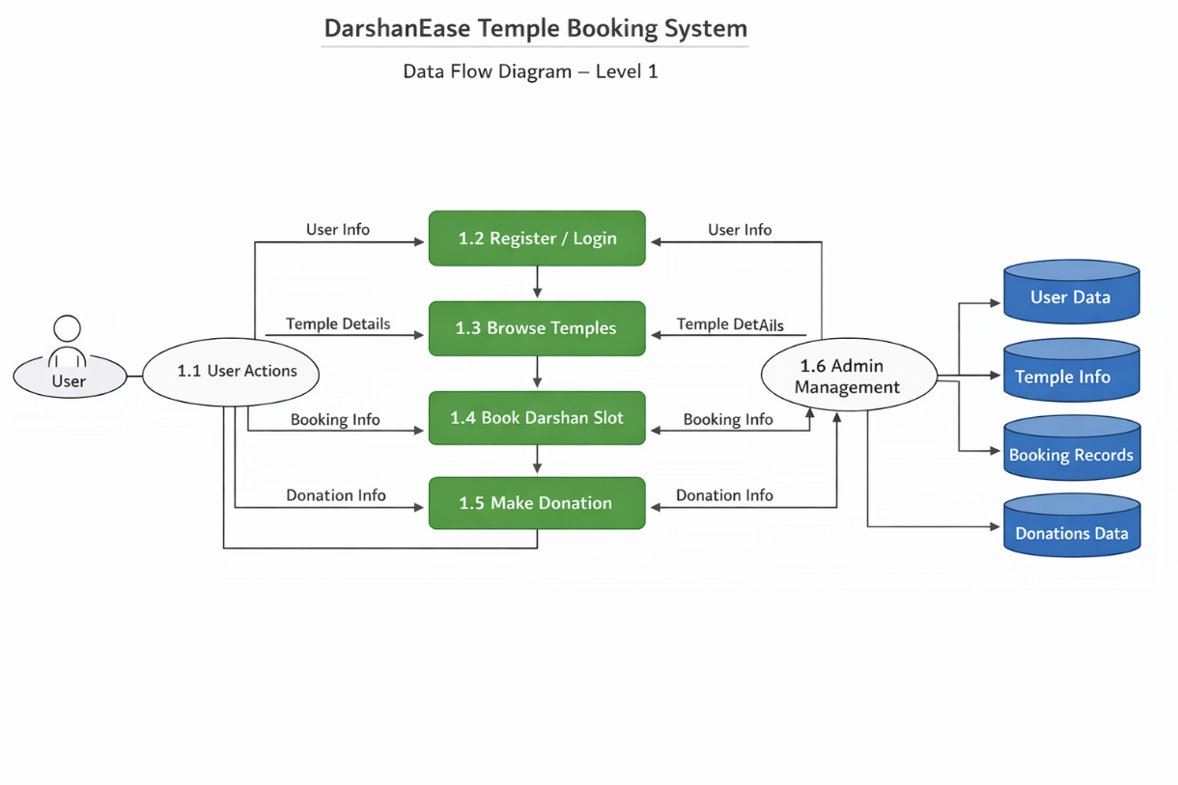

  - Technology Stack
The DarshanEase platform is developed using modern web technologies.
Frontend Technologies
- React.js
- HTML
- CSS
- JavaScript
Backend Technologies
- Node.js
- Express.js
Database
- MongoDB
Additional Tools
- JWT for authentication
- Cloudinary for image storage
- GitHub for version control
These technologies provide scalability, flexibility, and efficient system performance.

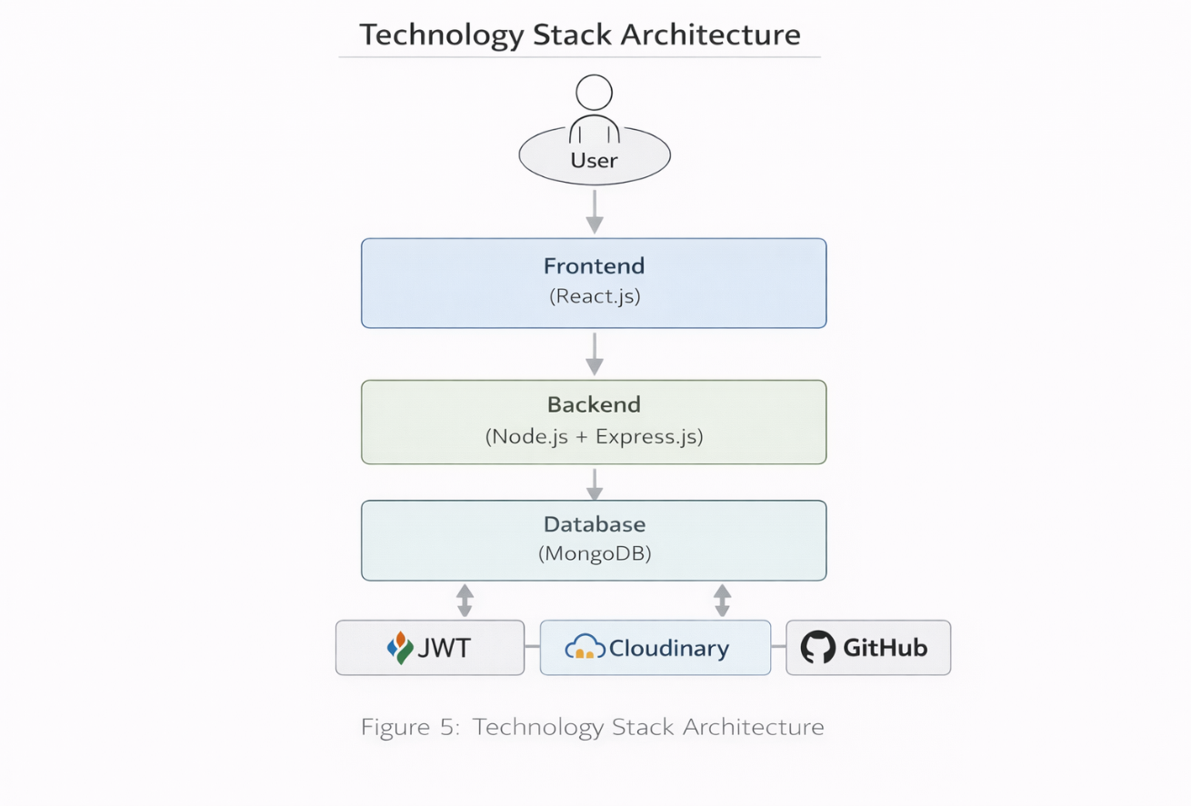
Figure : Technology Stack Architecture

- PROJECT DESIGN
  - Problem Solution Fit
The DarshanEase system effectively addresses the challenges associated with traditional temple ticket booking systems. By introducing an online booking platform, the system eliminates the need for devotees to wait in long queues and enables them to plan their visits more efficiently.
The platform also helps temple administrators manage visitor flow more effectively by providing structured booking slots.

  - Proposed Solution
The proposed solution is a web-based application that enables users to book temple darshan slots online. The platform provides an intuitive interface where users can browse temples, check available slots, and reserve bookings easily.
The system also provides administrative functionalities that allow temple administrators to manage temple information and darshan slots through a centralized dashboard.

  - Solution Architecture
The system architecture consists of three layers:
Frontend Layer
- Developed using React.js
- Provides the user interface for interacting with the system
Application Layer
- Built using Node.js and Express.js
- Handles business logic and API requests
Data Layer
- MongoDB database
- Stores users, temples, bookings, and donation records
This layered architecture ensures efficient communication between system components.
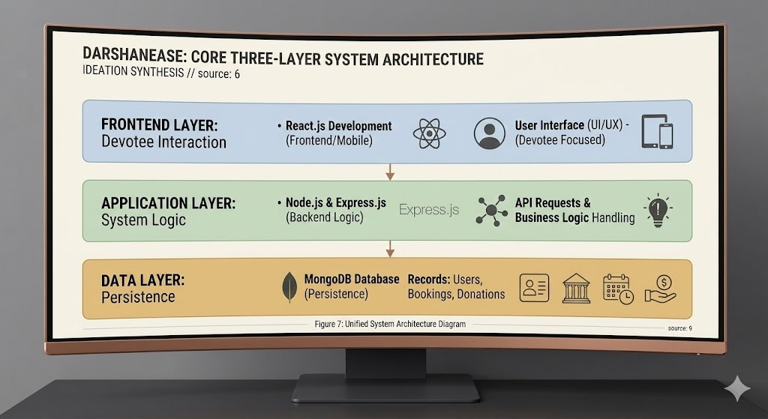
Figure : System Architecture Diagram

- PROJECT PLANNING & SCHEDULING
  - Project Planning
The project development followed the Agile methodology, where tasks were divided into multiple sprints.
Sprint 1
- User registration
- User login
- Temple listing
Sprint 2
- Darshan slot booking
- Booking history
Sprint 3
- Donation module
- Admin dashboard
This sprint-based approach allowed the team to implement and test features incrementally.

- FUNCTIONAL AND PERFORMANCE TESTING
  - Performance Testing
Testing was conducted to ensure that the system performs efficiently and meets functional requirements.
The following modules were tested:
- User authentication system
- Temple browsing functionality
- Darshan slot booking system
- Donation module
- Administrative management
The results confirmed that the application functions correctly and provides reliable performance under normal usage conditions.

- RESULTS
  - Output Screenshots
The results of the project are demonstrated through application screenshots showing the working system.
Key screenshots include:
- Home page
- Temple listing interface
- Darshan slot booking interface
- Booking confirmation page
- Admin dashboard
These screenshots confirm the successful implementation of the system features.

- ADVANTAGES & DISADVANTAGES
Advantages
- Reduces waiting time at temples
- Improves visitor management
- Provides convenient online booking
- Simple and user-friendly interface
Disadvantages
- Requires internet connectivity
- Depends on server availability
- Adoption may take time for some temples

- CONCLUSION
The DarshanEase system successfully demonstrates the implementation of a full-stack web application for temple darshan booking. By providing an online platform for slot reservations, the system improves convenience for devotees and enhances visitor management for temple authorities.
The project highlights the practical application of MERN stack technologies in solving real-world problems through digital solutions.

- FUTURE SCOPE
Several enhancements can further improve the DarshanEase platform:
- Development of a mobile application
- Integration of online payment gateways
- Multi-language support
- Integration with additional temples
- Advanced analytics for temple management

11. APPENDIX
GitHub Repository:
https://github.com/ayushahare/DarshanEase

